**Tunnel 0**

**West**

conf t

Enter configuration commands, one per line. End with CNTL/Z.

WEST(config)#interface g0/0

WEST(config-if)#ip address 172.16.1.1 255.255.255.252

WEST(config-if)#no sh

WEST(config-if)#exit

WEST(config)#interface s0/0/0

WEST(config-if)#ip address 10.1.1.1 255.255.255.252

WEST(config-if)#no sh

WEST(config-if)#exit

**ISP**

conf t

Enter configuration commands, one per line. End with CNTL/Z.

ISP(config)#interface s0/0/0

ISP(config-if)#ip address 10.1.1.2 255.255.255.252

ISP(config-if)#no sh

ISP(config-if)#exit

ISP(config)#interface s0/0/1

ISP(config-if)#ip address 10.2.2.2 255.255.255.252

ISP(config-if)#no sh

ISP(config-if)#exit

**East**

conf t

Enter configuration commands, one per line. End with CNTL/Z.

EAST(config)#interface s0/0/1

EAST(config-if)#ip address 10.2.2.1 255.255.255.252

EAST(config-if)#no sh

EAST(config-if)#exit

EAST(config)#interface g0/1

EAST(config-if)#ip address 172.16.2.1 255.255.255.252

EAST(config-if)#no sh

EAST(config-if)#exit

**West**

conf t

Enter configuration commands, one per line. End with CNTL/Z.

WEST(config)#interface s0/0/0

WEST(config-if)#clock rate 128000

WEST(config)#exit

WEST(config)#ip route 0.0.0.0 0.0.0.0 10.1.1.2

WEST(config)#ip route 0.0.0.0 0.0.0.0 10.2.2.1

WEST(config)#ip route 0.0.0.0 0.0.0.0 10.2.2.2

**ISP**

ISP#conf t

Enter configuration commands, one per line. End with CNTL/Z.

ISP(config)#ip route 0.0.0.0 0.0.0.0 10.1.1.1

ISP(config)#ip route 0.0.0.0 0.0.0.0 10.2.2.1

**East**

conf t

Enter configuration commands, one per line. End with CNTL/Z.

EAST(config)#interface s0/0/1

EAST(config-if)#clock rate 128000

EAST(config-if)#exit

EAST(config)#ip route 0.0.0.0 0.0.0.0 10.1.1.1

EAST(config)#ip route 0.0.0.0 0.0.0.0 10.1.1.2

EAST(config)#ip route 0.0.0.0 0.0.0.0 10.2.2.2

EAST(config)#ip route 172.16.1.0 255.255.255.0 172.16.2.0

EAST(config)#ip route 172.16.1.0 255.255.255.0 172.16.12.2

**West**

conf t

Enter configuration commands, one per line. End with CNTL/Z.

WEST(config)#interface tunnel 0

WEST(config-if)#

%LINK-5-CHANGED: Interface Tunnel0, changed state to up

WEST(config-if)#ip address 172.16.12.1 255.255.255.252

WEST(config-if)#tunnel source s0/0/0

WEST(config-if)#tunnel destination 10.2.2.1

WEST(config-if)#

%LINEPROTO-5-UPDOWN: Line protocol on Interface Tunnel0, changed state to up

WEST(config-if)#do write mem

**East**

conf t

Enter configuration commands, one per line. End with CNTL/Z.

EAST(config)#interface tunnel 0

EAST(config-if)#

%LINK-5-CHANGED: Interface Tunnel0, changed state to up

EAST(config-if)#ip address 172.16.12.2 255.255.255.252

EAST(config-if)#tunnel source s0/0/1

EAST(config-if)#tunnel destination 10.1.1.1

EAST(config-if)#

%LINEPROTO-5-UPDOWN: Line protocol on Interface Tunnel0, changed state to up

EAST(config-if)#do write mem

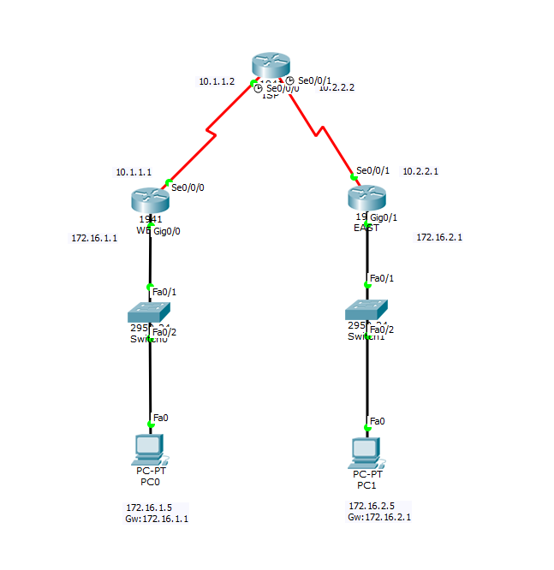

47AY-XFCO-ZWYS-WI5

47AY-XFCO-ZWYS-WI5